Brandon Kindrick

Daniel Williamson

CS 136L

Due: February 16, 2016

**Lab 3: Painting Cars**

**Problem Statement:**

In this lab we were tasked with making a program that creates car classes, draws them and has the ability to paint them. This requires us to have three classes. A paint bucket class, a car class, and a Frame class. We ended up also making a car component class which allowed us to change the size and shape of the car. The paint bucket class was used to make custom colors that could be applied to the car and the car frame class which is where we drew our cars..

**Planning:**

Planning for this lab, we started by following the book's instructions on making a car class. This also required us to make a Car Frame class which built a JFrame. We drew our cars in this frame. To edit the car sizes, wheel placement and the placement of the wind shield. After constructing these classes, the rest of the lab was straight forward.

**Implementation and Testing:**

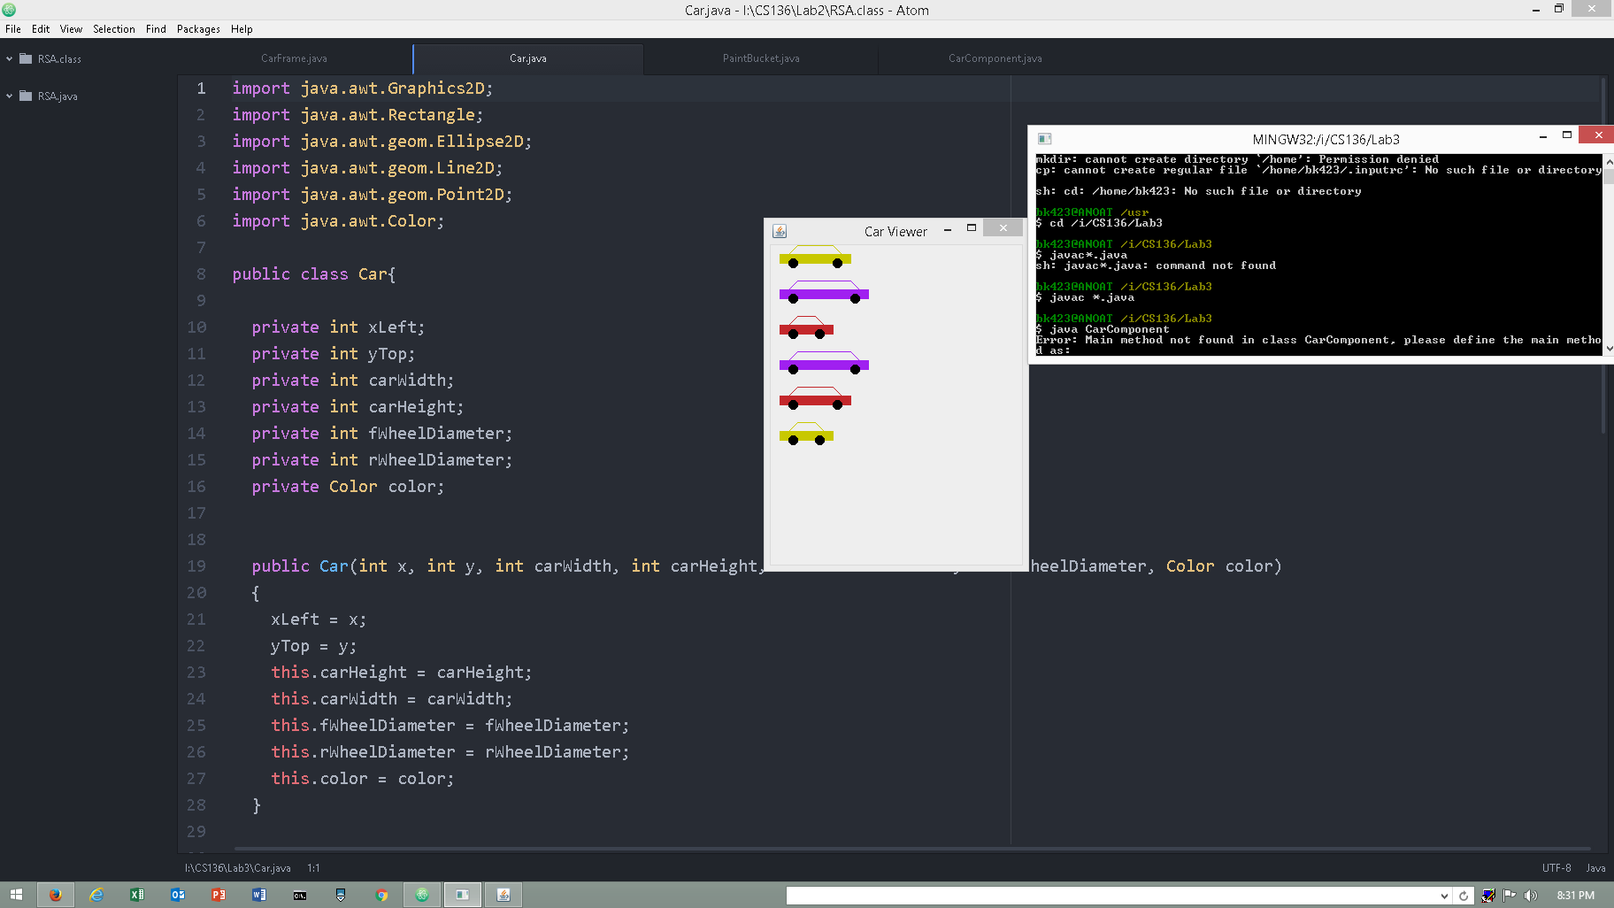After some trial and error, we were able to get the car’s tires to line up properly when stretching/ shrinking the cars. This was even harder when it came to the wind shields.

**Reflection:**

This lab wasn't incredibly difficult. The hardest part was getting the cars to draw correctly. Especially getting the different sized cars to draw correctly. Once this was accomplished this rest of the lab was straight forward.